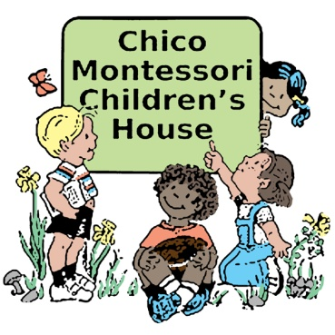
Spring Term 2023 Event Calendar
____________________________________________________________________________________________________________________________
Monday, January 9 First day of Spring Term

Monday, January 16 Martin Luther King, Jr. Day NO SCHOOL
___________________________________________________________________________________
Friday, February 17 President’s Days NO SCHOOL
and Monday, February 20 NO SCHOOL
Monday, March 6 Summer Camp Registration Open to Current Students
______________________________________________________________________________________________________________________
Friday, March 10 Parent teacher conferences NO SCHOOL
Return forms go home

March 13 – 17 Spring Break NO SCHOOL

Monday, March 27 Summer Camp Registration Open to Public
__________________________________________________________________________________________________________________
Monday, April 3 Fall 2023 Return forms DUE (includes siblings)

Tuesday, April 10 Registration Open for Wait List

Friday, April 7 Travel Days NO SCHOOL
and Monday, April 10 NO SCHOOL
Saturday, April 22 Walk-A-Thon at school
____________________________________________________________________________________________________________________________
Saturday, May 6 Open House for new families 9:30 – 11:30am
Fall Registration open to Public

Thursday, May 25 Last Day of School

Friday, May 26 Family Picnic Hooker Oak Park
____________________________________________________________________________________________________________________________

May 31-June 3 Prep for Summer Camps NO SCHOOL

Monday, June 5 First day of Summer Camp

**Fall Term begins Tuesday, August 22, 2023**

